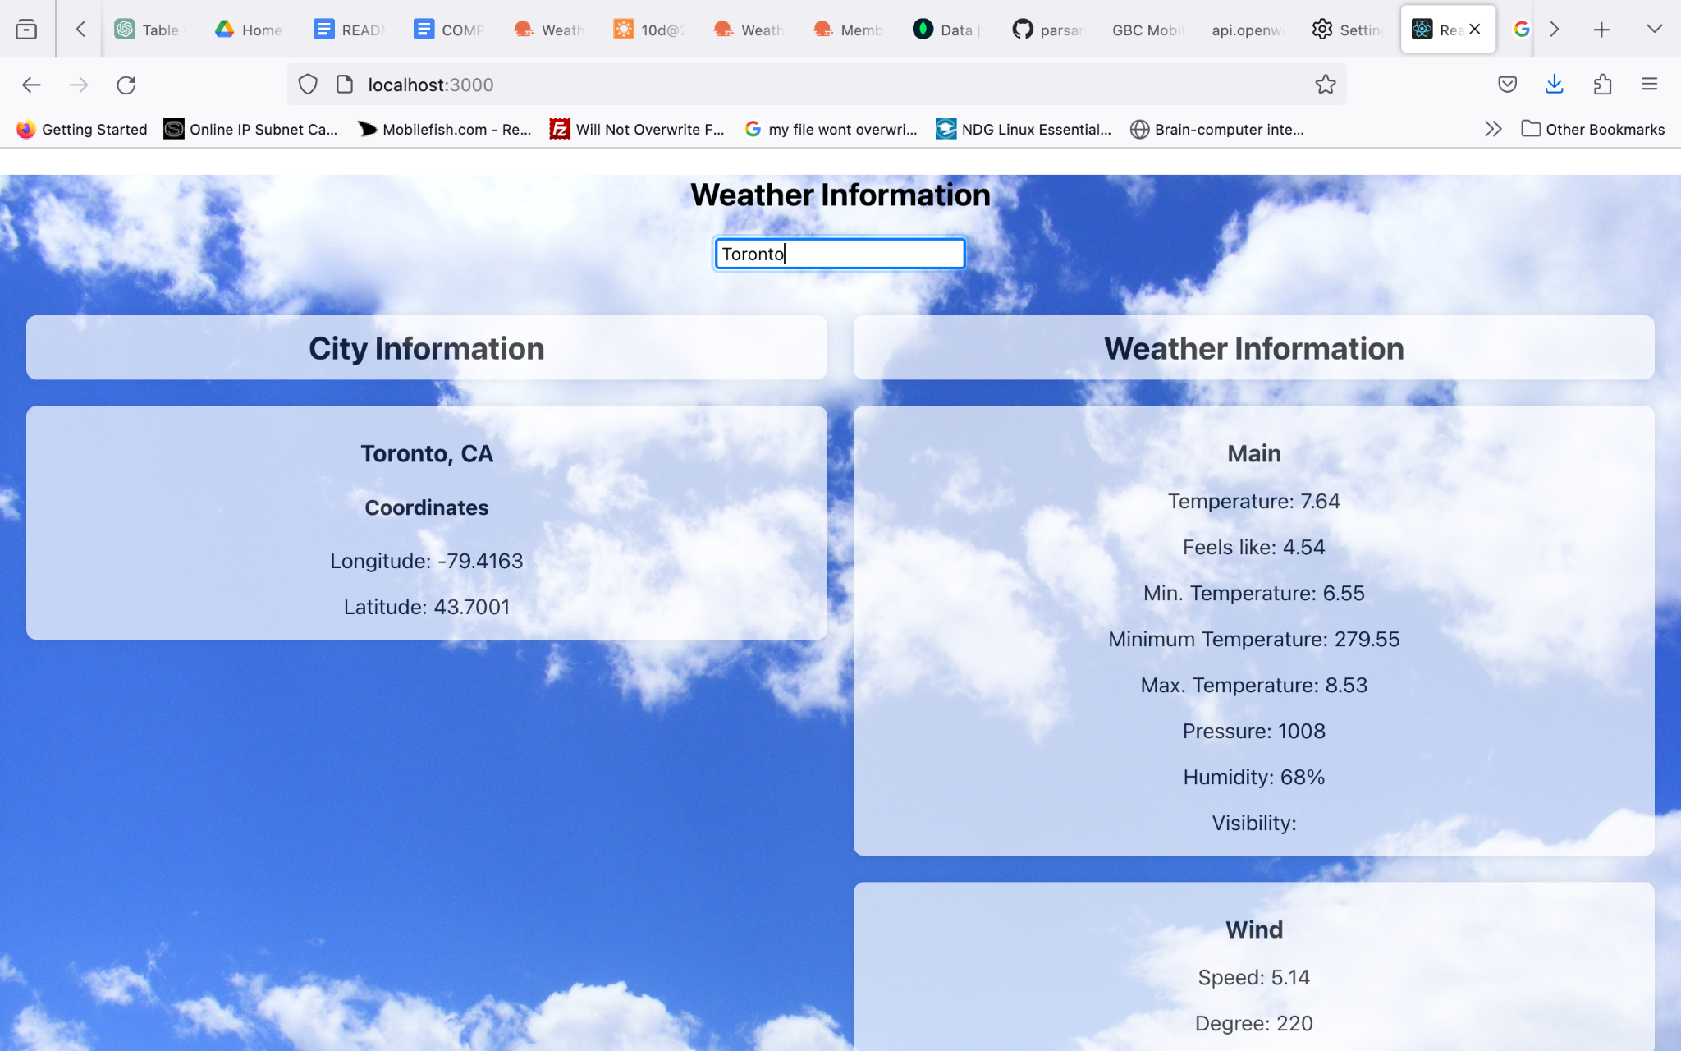

This output shows that the user has entered Toronto as the city name and the React application passes it as part of the appropriate URL to fetch associated data.

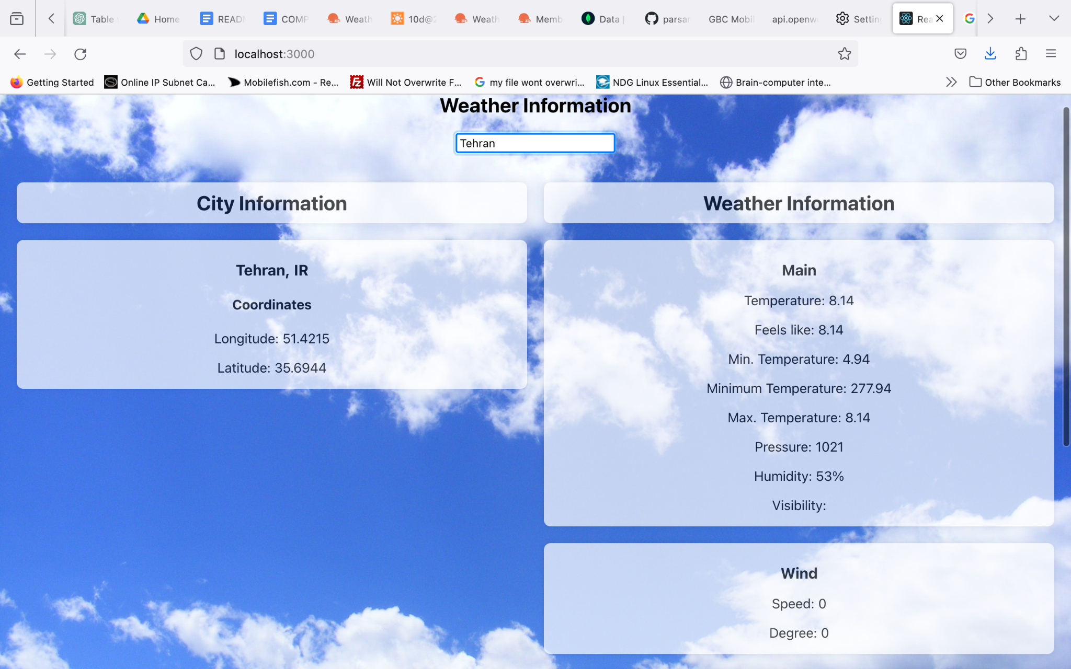

This output shows that the user has entered Tehran as the city name and the React application passes it as part of the appropriate URL (q=Tehran) and the API to fetch associated data.

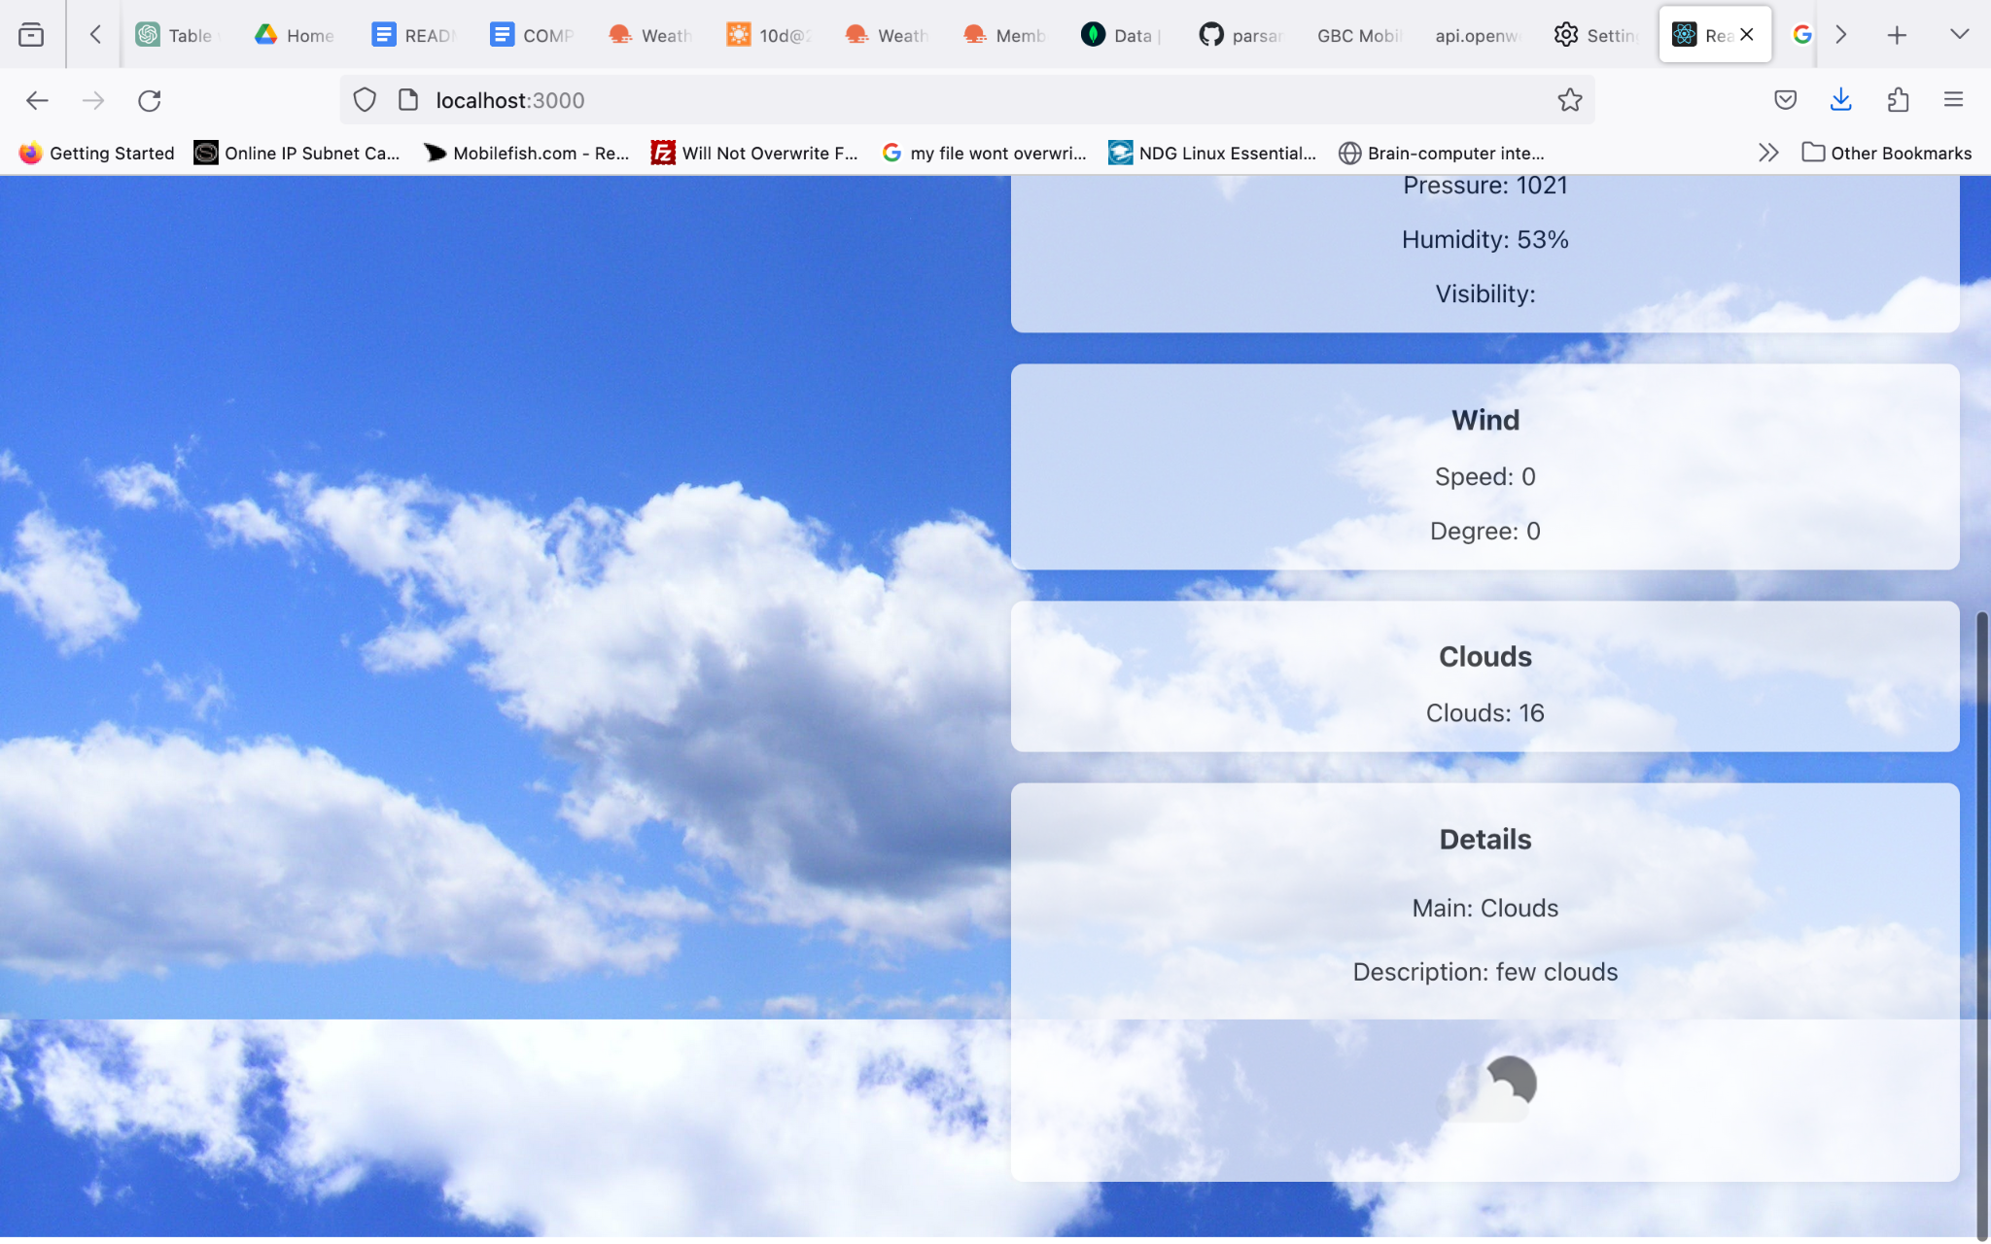

The rest of the output as shown above:

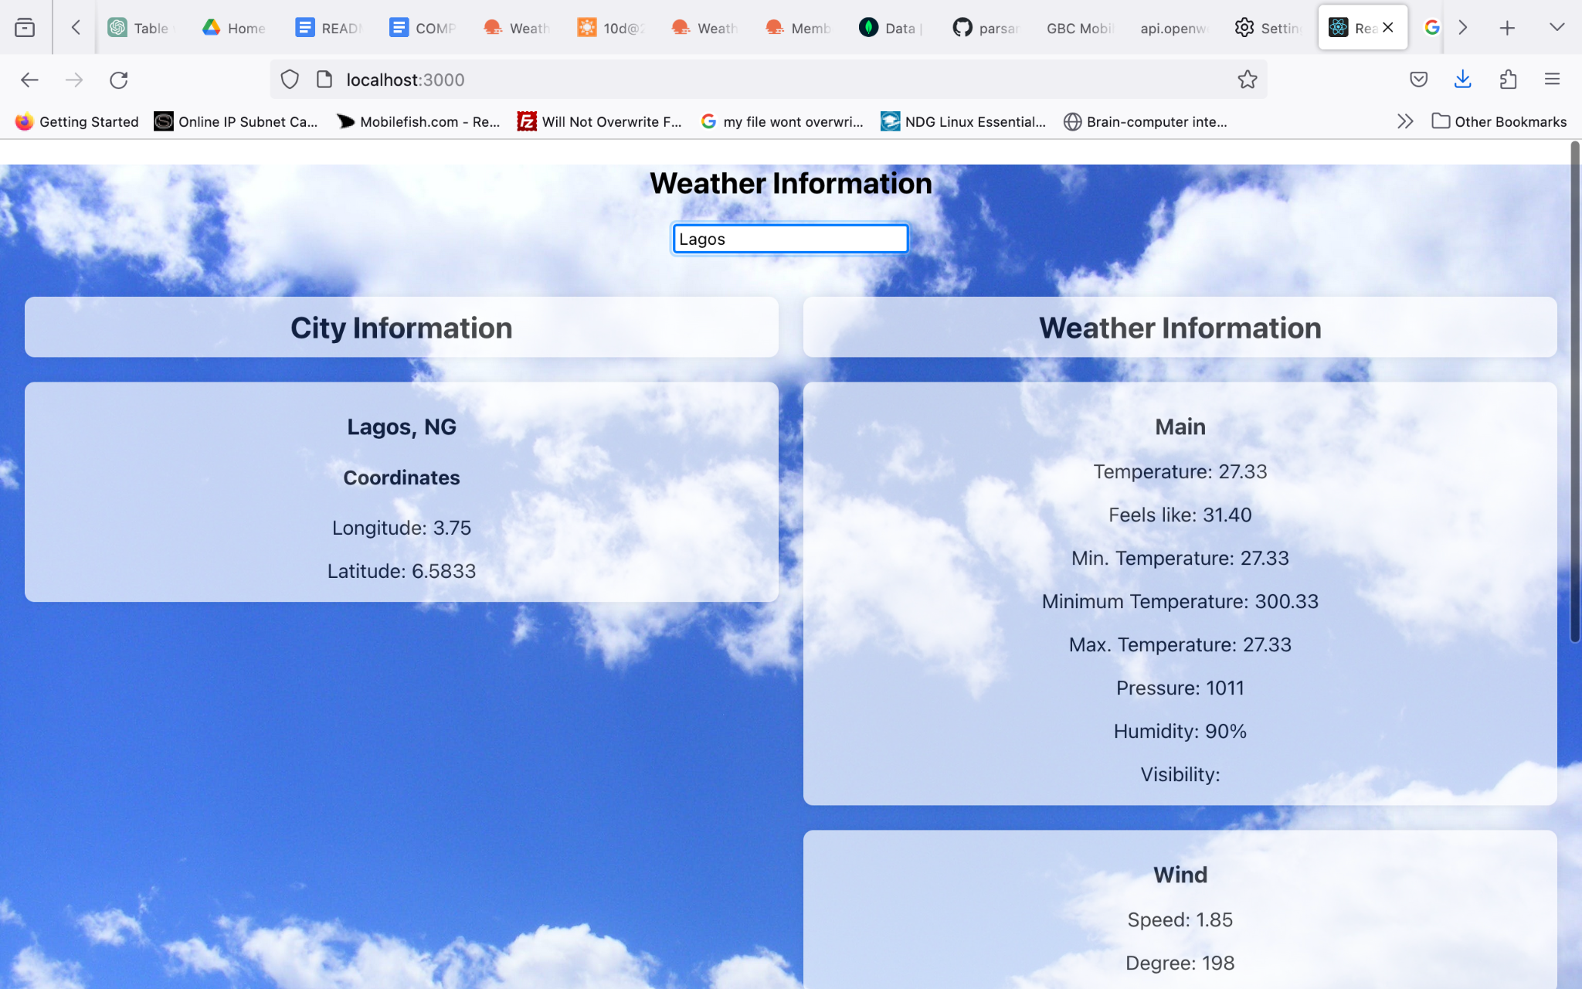

This output shows that the user has entered Lagos as the city name and the React application passes it as part of the appropriate URL to fetch associated data.

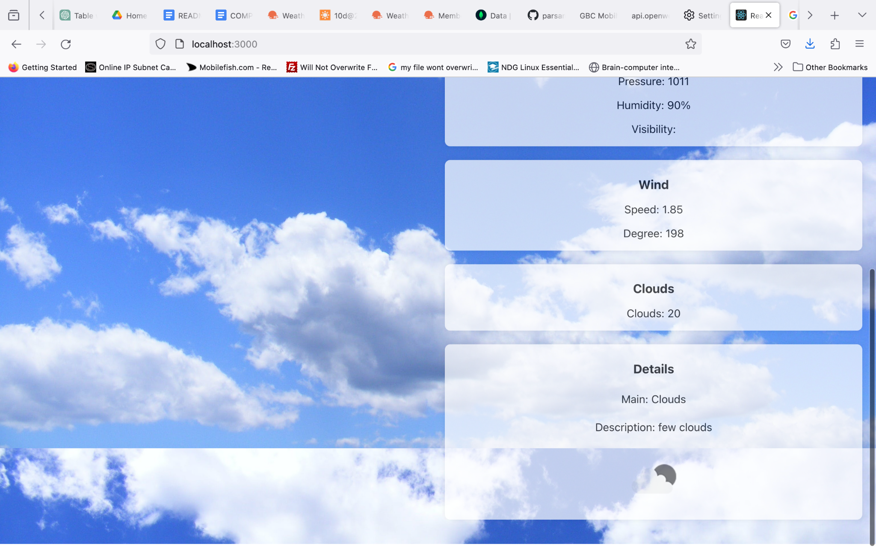

The rest of the output as shown above:

**GitHub Repository Link:**

[**https://github.com/parsamd1/101356047_comp3123_labtest2.git**](https://github.com/parsamd1/101356047_comp3123_labtest2.git)